3rd South Caucasus Security Forum (SCSF) 2015

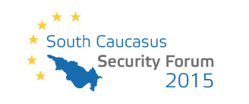



Tbilisi, 26-27 October 2015

Venue: Hotel Holiday Inn Tbilisi, 26 May Square, Tbilisi 0171, Georgia

Official language of the 3rd South Caucasus Security Forum 2015 is English.
#SCSF2015

PRELIMINARY PROGRAM

DAY 1 - MONDAY, 26 OCTOBER 2015

09.00-09.40 REGISTRATION (Security check, Prime Minister Details)

09.40-10.00 OFFICIAL WELCOME
Tinatin Khidasheli, Minister of Defence of Georgia
Róbert Ondrejcsák, Director, CENAA
Kakha Gogolashvili, Director of EU Studies, GFSIS

10.00-10.20 Special Address by Irakli Garibashvili, Prime Minister of Georgia;

10.20-10.30 SHORT COFFEE BREAK

10.30-12.00 SESSION 1: Euro-Atlantic security: Georgia - a staunch aspirant on
NATO`s eastern edge
Tinatin Khidasheli, Minister of Defence of Georgia
David Bakradze, State Minister of Georgia on European and Euro-Atlantic Integration
James Appathurai, Deputy Assistant Secretary General
Amb. Lauri Lepik, Ambassador of Estonia to NATO
Amb. Kęstutis Jankauskas, Head of EUMM to Georgia
Chaired by: Mikheil Darchiashvili, Former Deputy Minister of Defence, Georgia

12.00-13.30 NETWORKING LUNCH

13.30-15.00 SESSION 2: Information Warfare and its Strategic Consequences
Levan Dolidze, Ambassador, Founder and Director of Centre for Security and Development of Georgia
Liudas Zdanavičius, Lecturer, Military Academy of Latvia
Taras Mykhalniuk, Director, Open Ukraine, Arseniy Yatsenyuk Foundation, Ukraine
Amb. Giorgi Badridze, Senior Fellow, GFSIS
Arkady Moshes, Programme Director, The EUs Eastern Neighbourhood and Russia research programme, The Finish Institute of International Affairs
Chaired by: Mirek Tóda, Journalist, Denník N

15.00-15.30 COFFEE BREAK

15.30-17.00 SESSION 3: NATO and its Partners before the Warsaw Summit 2016
Nodar Kharshiladze, Senior Fellow, GFSIS, Georgia
Grigoriy Perepelytsia, Director, Foreign Policy Institute, Ukrainian Diplomatic Academy
Marijus Velička, Vice Minister of National Defence of the Republic of Lithuania
Alexandre Maisuradze, Ambassador of Georgia to NATO
Daniel Ioniţă, State Secretary of the Ministry of Foreign Affairs of Romania
Chaired by: Peter Bátor, Adviser to the President of Slovakia

17.00-17.30 COFFEE BREAK

20.00-22.00 GALA DINNER (upon separate invitations only)

SPECIAL DINNER KEYNOTE SPEECH

DAY 2 - TUESDAY, 27 OCTOBER 2015

09.00-09.20 SCSF KEYNOTE
David Usupashvili, Chairman of the Parliament of Georgia

09.20-10.50 SESSION 4: Hybrid Warfare and its Implications for NATO Members and Partners
Col. Omar Begoidze, Deputy Chief of General Staff, Georgia
Ivan Jestřáb, Juniur Deputy Minister - Political Director, Ministry of Foreign Affairs of the Czech Republic
Dr. Ariel Cohen, Senior Fellow, the Atlantic Council and Director, Center for Energy, Natural Resources and Geopolitics at the Institute for the Analysis of Global Security
Brigadier General Matt Brand (Ret), former Deputy Chief of Staff Strategic Plans and Policy, NATO Allied Command Transformation
Richard Weitz, Director and Senior Fellow, Center for Political-Military Analysis, Hudson Institute
Chaired by: James C. O'Brien, Vice Chair, Albright Stonebridge Group;

10.50-11.10 COFFEE BREAK

11.10-12.40 SESSION 5: Black Sea - Military Balance and Cooperation
Tornike Sharashenidze, GIPA, Georgia
Hanna Shelest, Editor in Chief, Ukraine Analytica, Ukraine
Richard Giragosian, Director, Regional Studies Center Foundation (RSC), Armenia
Sergey Utkin, Head of Department, Centre for Situation Analysis (CSA), Russian Academy of Sciences
Iulian Chifu, former advisor to Romanian President
Luke Coffey, Margaret Thatcher Fellow; The Davis Institute for National Security and Foreign Policy at The Heritage Foundation
Chaired by: Michael Cecire, Associate Scholar, Foreign Policy Research Institute

12.40-14.10 NETWORKING LUNCH

14.10-15.40 SESSION 6: Changes in the Middle East: ISIS and Beyond
Kamal Namig og. Makili-Aliyev, Leading Research Fellow, Foreign Policy Analysis Department, Center for Strategic Studies under the president of the Republic of Azerbaijan
Mate Szalai, Institute for Foreign Affairs and Trade, Hungary
Cuneyt Gurer, Chief of Migration Management and Foreigners Service Department of Sivas Provincial Police, Turkey
David Chochua, expert on terrorism, Director, Department of Americas, MFA of Georgia
Mr. Josip Brkić, Deputy Minister of Foreign Affairs of Bosnia and Herzegovina;
Chaired by: Tengiz Pkhaladze, Georgian President Giorgi Margvelashvili's adviser for foreign relations

15.40-16.10 COFFEE BREAK

16.10-17.40 SESSION 7: Ukraine Crisis Challenging Europe’s Security
Architecture: Threat of the Domino effect?
Oleksandr Lytvynenko, Deputy Secretary of the National Security and Defence Council of Ukraine
Aurel Fondos, State Secretary of the Ministry of Defense of the Republic of Moldova
Roman Jakic, Former Minister of Defence of Slovenia
Andreas Peschke, Ambassador, Director for Eastern Europe, the Caucasus and Central Asia, Federal Foreign Office, Federal Republic of
Germany
Lincoln Mitchell, Scholar, Arnold A. Saltzman Institute of War and Peace Studies, Columbia University
Róbert Ondrejcsák, Director, CENAA

Chaired by: Brooks Tigner, Jane’s Defence Weekly

17.40-18.00 CLOSING REMARKS AND SUMMARY
Tinatin Khidasheli, Minister of Defence of Georgia
Róbert Ondrejcsák, Director, CENAA
Kakha Gogolashvili, Director of EU Studies, GFSIS

18.20-18.50 CLOSED SESSION WITH JOURNALISTS

Organizers


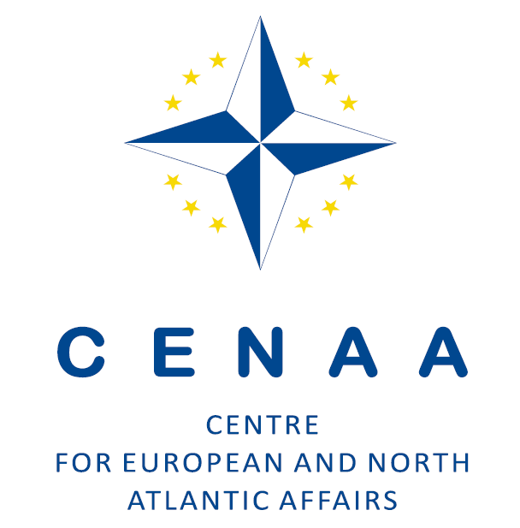
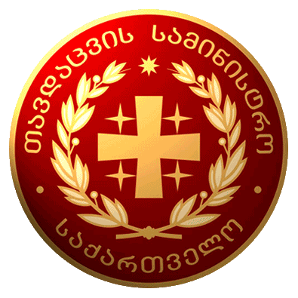

Ministry of Defence of Georgia

Strategic Partners

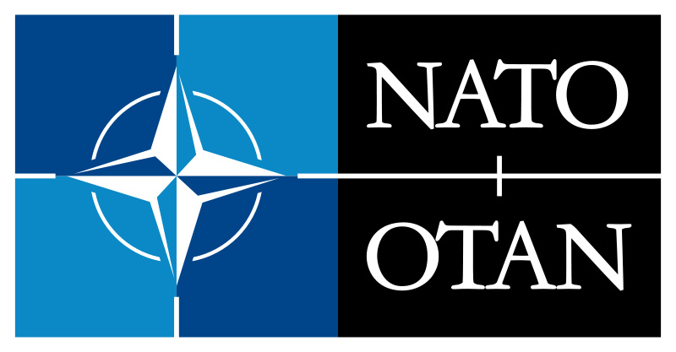

Special Partner



Partners

Faculty of Social Sciences, Charles University Prague, Czech Republic
Antall József Knowledge Centre of Political and Social Sciences, Hungary
The Polish Institute of International Affairs (PISM), Poland
Open Ukraine, Arseniy Yatsenyuk Foundation, Ukraine
Regional Studies Center Foundation (RSC), Armenia
Khazar University, Azerbaijan



